HDOC DAY-36
NAME-Priyadarshna
Sapidi-590032928
Batch-15
QUESTION:
Write a menu-driven C program using separate functions to:
- Count characters in a string without using built-in length functions.
- Print each character of the string on a new line.
- Count vowels and consonants in the string.
- Exit the program.

Aim:
To write a menu-driven C program using separate functions to perform different string operations.
Algorithm
- Start.
- Enter a string.
- Display the menu.
- Enter the user's choice.
- Call the required function according to the choice.
- Display the result.
- Repeat until Exit is selected.
- Stop.
Functions Used
- countCharacters() – Counts the number of characters in the string.
- printCharacters() – Prints each character on a new line.
- countVC() – Counts the vowels and consonants in the string.
- main() – Displays the menu and controls the program.

>C PROGRAM:
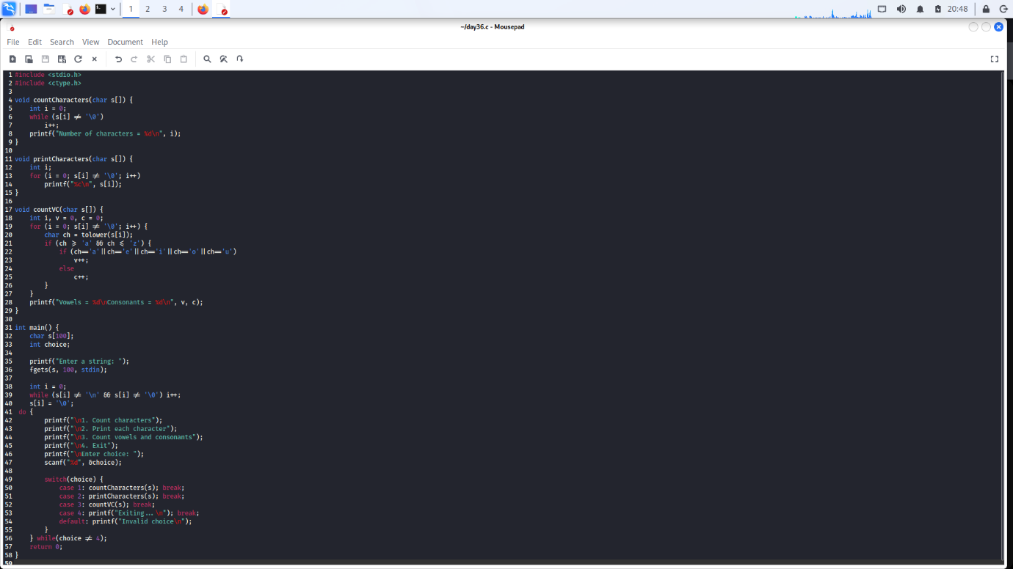

>OUTPUT:
